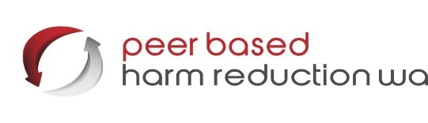

TAX INVOICE
ABN: 90 058 632 943
2024/2025 ANNUAL MEMBERSHIP

Peer Based Harm Reduction WA aims to improve the health and social circumstances of people who use/inject illicit substances. Membership is open to individuals and groups who support the objectives of the organisation.

NAME:

ORGANISATION: (if relevant)
Address:
Suburb: | Postcode:
Telephone: (Home) | (Work)
Email:

Type of Membership (Please tick)

Unwaged ($2)

Waged ($10)

Organisation ($50)

Membership fees are GST inclusive.

Cash / cheque: Suite 22, 7 Aberdeen St Perth. P.O Box 8003 WA 6849
Direct deposit: Peer Based Harm Reduction WA, Westpac,
BSB: 036004, account:124953 (please reference with your name & membership type) Or contact us:
T: (08) 9325 8387
E: finance@harmreductionwa.org

Upon admission as a member of Peer Based Harm Reduction WA I agree to abide by the Rules of the Association.

Signed……………………………….. Date…………………………
Suite 22, 7 Aberdeen St Perth. Po Box 8003 WA 6849
P: 08 9325 8387 F: 08 9325 6152 E: finance@harmreductionwa.org

